**ASSIGNMENT – 2A**

**Activity 9:**For activity #9, you must re -create a new version of the Web site you created for Assignment   
1A (activity #1), only this time you must use only CSS to achieve the same design.   
• Include heading h1 should be of size 16 and highlights with color of your choice   
• Sub heading for each paragraph using h2 and all sub headings should be of size 14   
and color “green”   
• Use different font family for all three paragraphs and should be font-size 12.   
• All the paragraph contents should be aligned with justify.   
• Use div element to differentiate each paragraph. (Hint: use background-color)   
• Apply vertical text of your choice.   
• Display the overflowed content when hovering over the element.   
• Display your image as rounded images and create drop-shadow effect to an image.   
• Use the border property to create thumbnail images.   
Note: Include your CSS style as a container

**Aim:**

To recreate the website design from Assignment 1A using only CSS, focusing on styling headings, paragraphs, and images, applying alignment, background colors, vertical text, hover effects, and advanced image customization techniques.

**HTML and CSS Tags need to be used:**

| **HTML Tags** | **HTML Attributes** | **CSS Style Selectors** | **CSS Style Properties** |
| --- | --- | --- | --- |
| <!DOCTYPE> | lang="en" | body | font-family, color, background-color, margin, padding |
| <html> | lang="en" | header | text-align, background-color, color, padding |
| <head> | charset="UTF-8", name="viewport", content="..." | h1 | font-size, color |
| <meta> | charset, name, content | h2 | font-size, color, font-style |
| <title> | None | .content | max-width, margin, padding, background-color, box-shadow |
| <style> | None | p | text-align, line-height |
| <body> | None | .para1, .para2, .para3 | font-family |
| <header> | None | .highlight | font-weight, color |
| <h1> | None | .important | font-weight, font-size |
| <h2> | None | .emphasized | font-style, color |
| <div> | style="background-color: ..." | img | float, margin-right, margin-top, border-radius, width, height, border, box-shadow |
| <p> | class="para1", class="para2", class="para3" | footer | text-align, padding, background-color, color, position, width, bottom |
| <img> | src="Pic.jpg", alt="Error loading the image" | Inline style attributes | background-color, font-family in div tags for paragraphs; CSS inside <style> applies to classes and tags directly. |
| <footer> | None | Inline div | Each div has inline styles (background-color) applied for paragraph separation. |

**Code:**

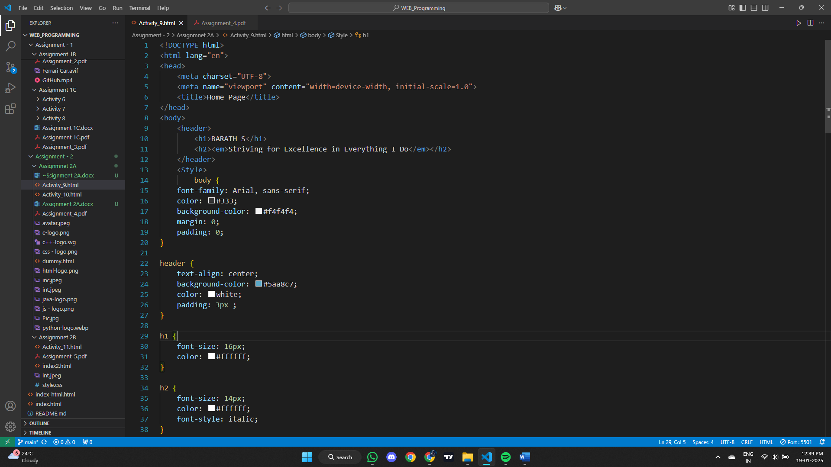

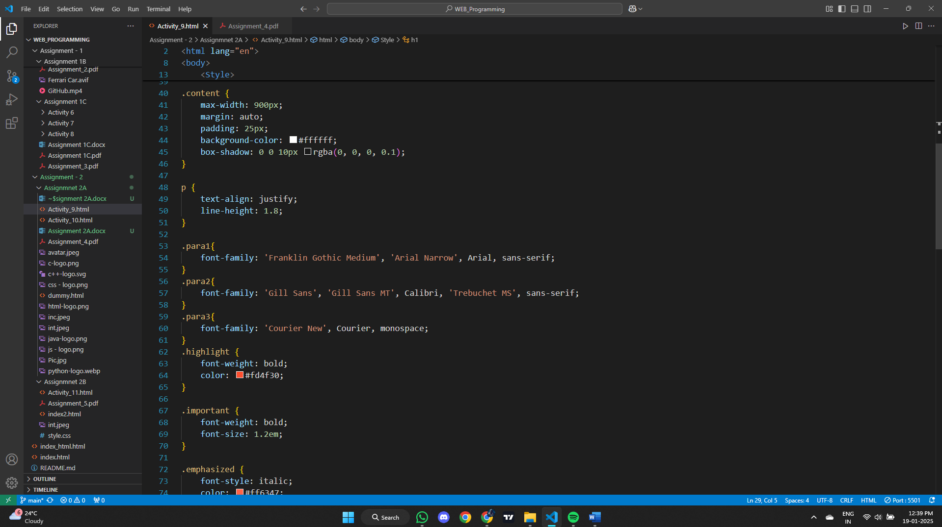

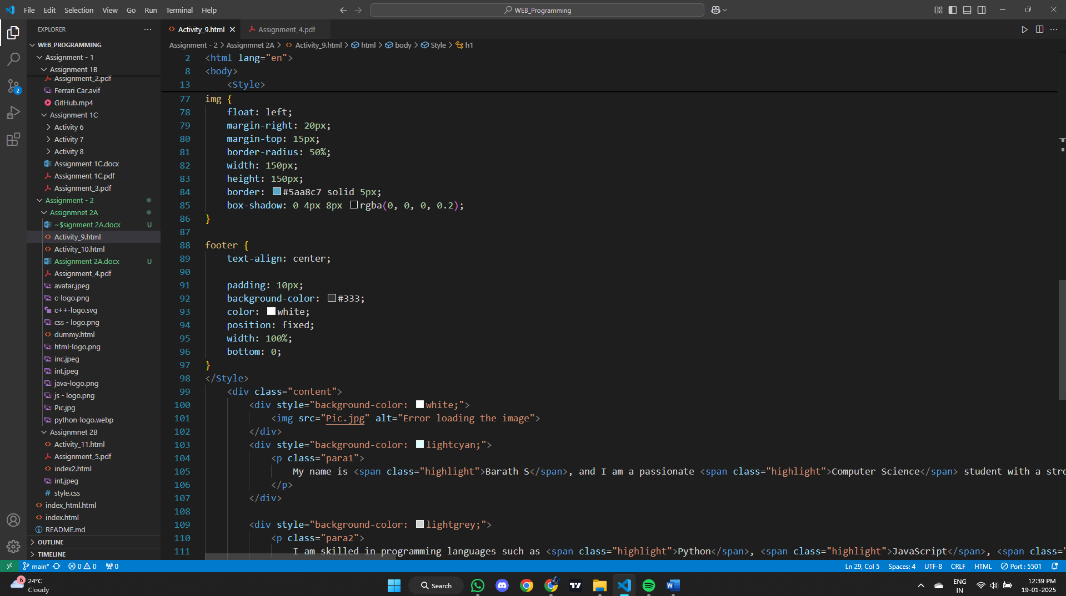

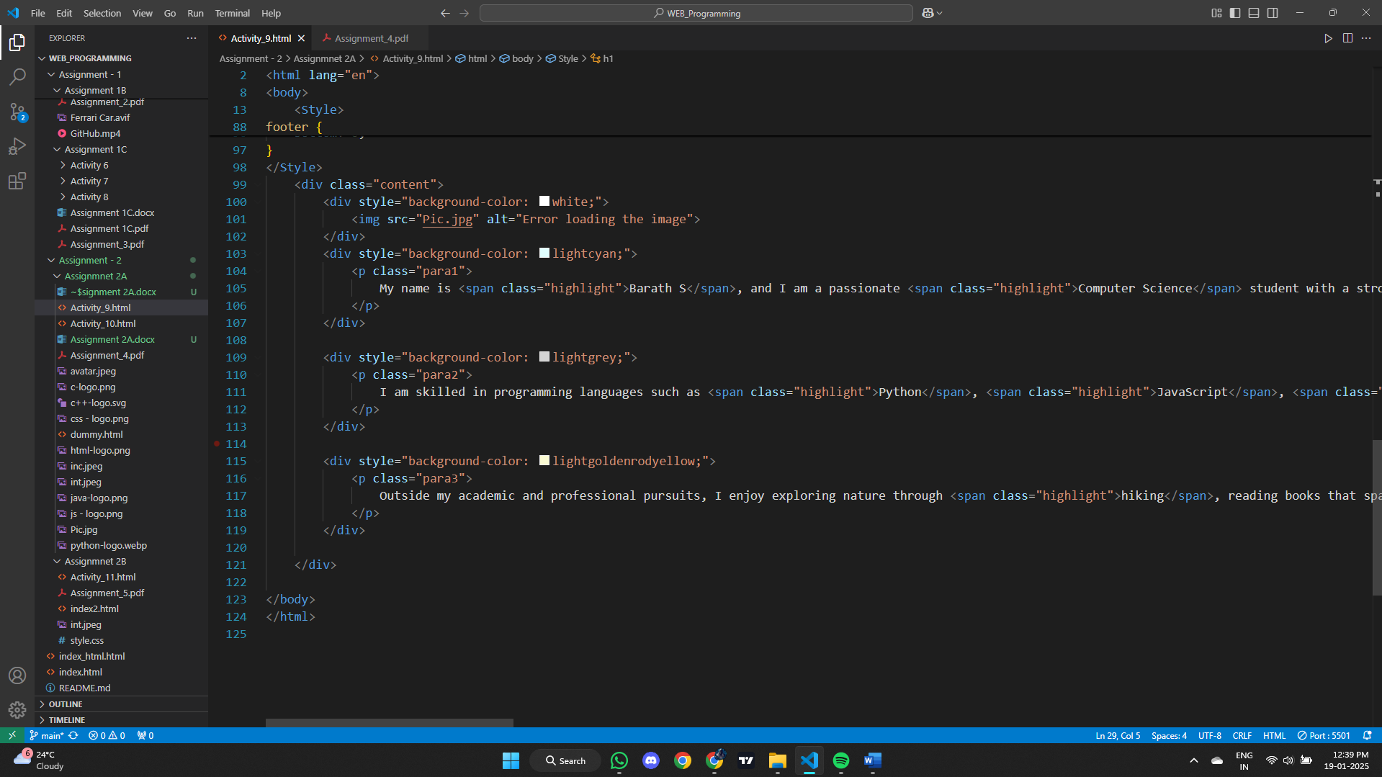

**Output:**

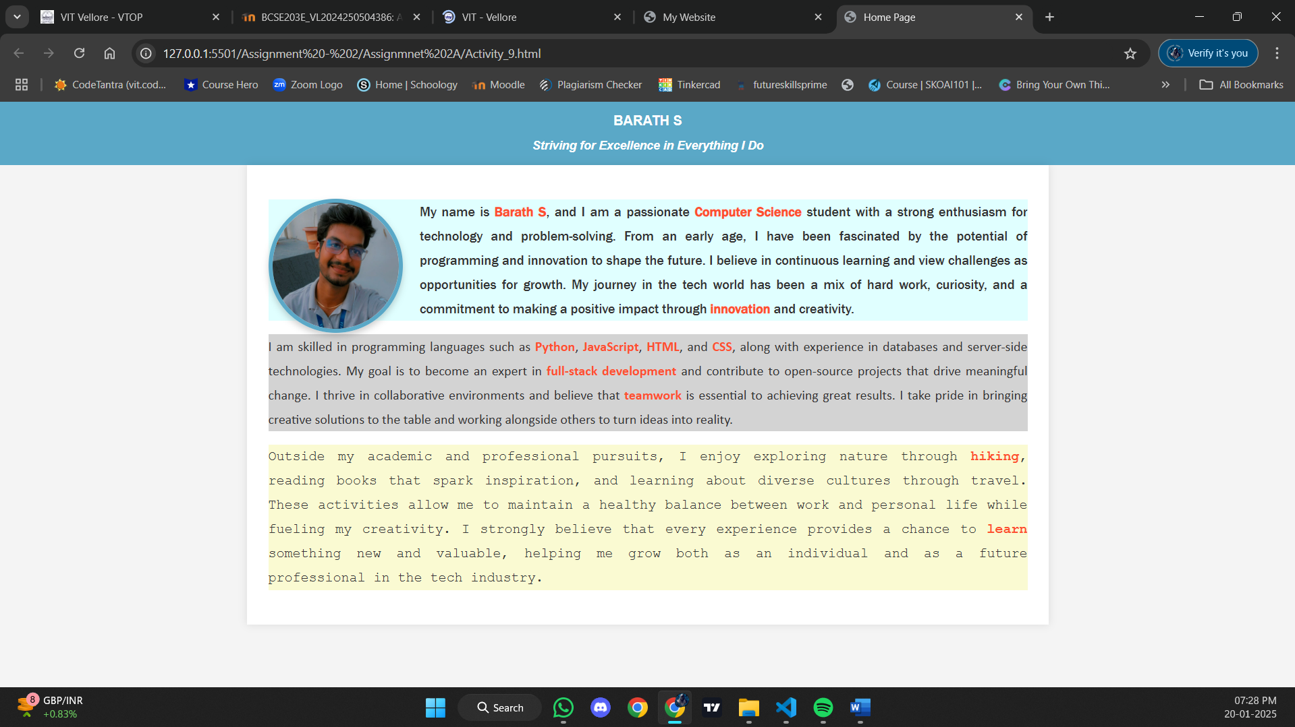

**Result:**

Thus, a web page design to replicate the above table and the output was verified

**Activity 10:**

For activity #10, you must re -create a new version of the Web site you created for Assignment   
1A (activity #2), only this time you must use only CSS to achieve the same design.   
• List of courses in Winter 2024-2025.   
 -Differentiate theory and lab classes with colors, font   
• List the programming languages and provide rating yourself out of 10.   
 -Use image as a list item marker (Hint: Clipart / Logo can be used)   
• Add reviews or book summary of your 3 favourite movies/books/TV shows/ music   
concert. (Apply any style of your choice)   
Note: Include your CSS style as an attribute and use minimum any two selector of your   
choice

**Aim:**  
To recreate a website design from Assignment 1A using only CSS, incorporating a list of courses for Winter 2024-2025 with differentiated theory and lab classes, a list of programming languages with self-ratings, and reviews or summaries for three favorite movies/books/TV shows/music concerts. The design should demonstrate proficiency in CSS by applying a minimum of two selectors and style attributes to achieve a visually appealing and functional website.

**HTML tags, HTML attributes, CSS style selectors, and CSS style properties used:**

| **HTML Tags Used** | **HTML Attributes** | **CSS Style Selectors** | **CSS Style Properties** |
| --- | --- | --- | --- |
| <!DOCTYPE html> | lang (in <html>) | body | font-family, color, background-color, margin, padding |
| <html> | charset, viewport (in <meta>) | header, footer | text-align, background-color, color, padding, font-size, font-weight |
| <head> | charset, name, content (in <meta>) | h2 | color, font-weight, font-family, text-decoration, margin-bottom |
| <meta> | charset, name, content | .course-list, .language-list | font-size, margin-left, line-height |
| <title> |  | .course-list b | color |
| <body> |  | .theory | color, font-weight |
| <header> |  | .lab | color, font-weight |
| <footer> |  | .language-list | list-style, padding-left |
| <h1>, <h2>, <dt>, <dd> |  | .language-list li | margin-bottom, display, align-items, font-size, border-radius, border |
| <ul>, <li> |  | .rating | color, font-weight |
| <span> |  | .movie-title, .movie-description | font-size, font-weight, color, text-transform, font-style |
| <img> | src, alt, width, height | .movie-info | font-size, font-weight, color |
| <div>, <section>, <footer> |  | .image | width, height, object-fit, box-shadow, margin-top, margin-bottom |
| <dl>, <dt>, <dd> |  | .movie-reviews | margin-left |
| </body>, </html> |  |  |  |

**Code:**

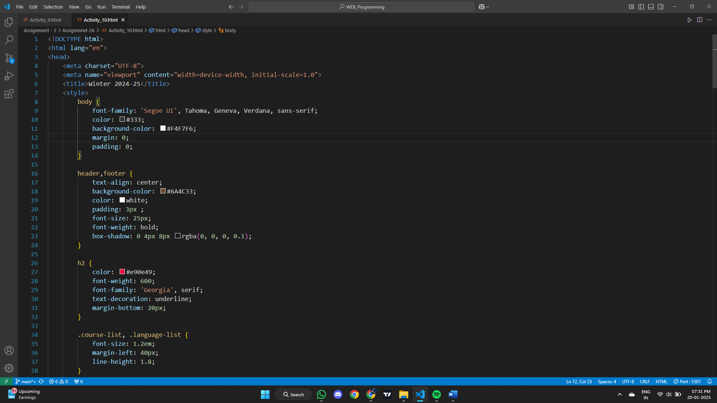

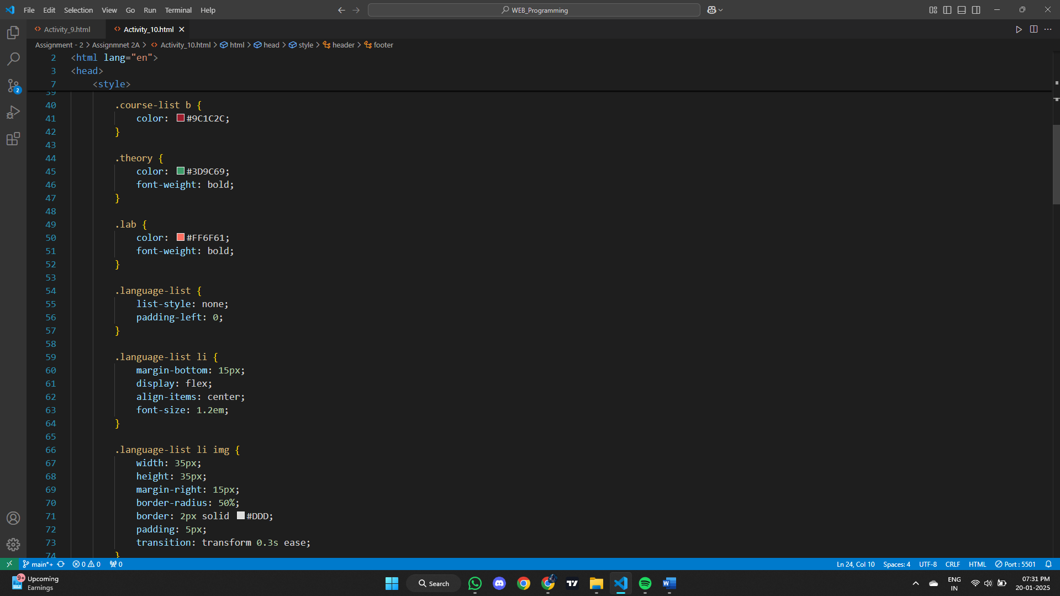

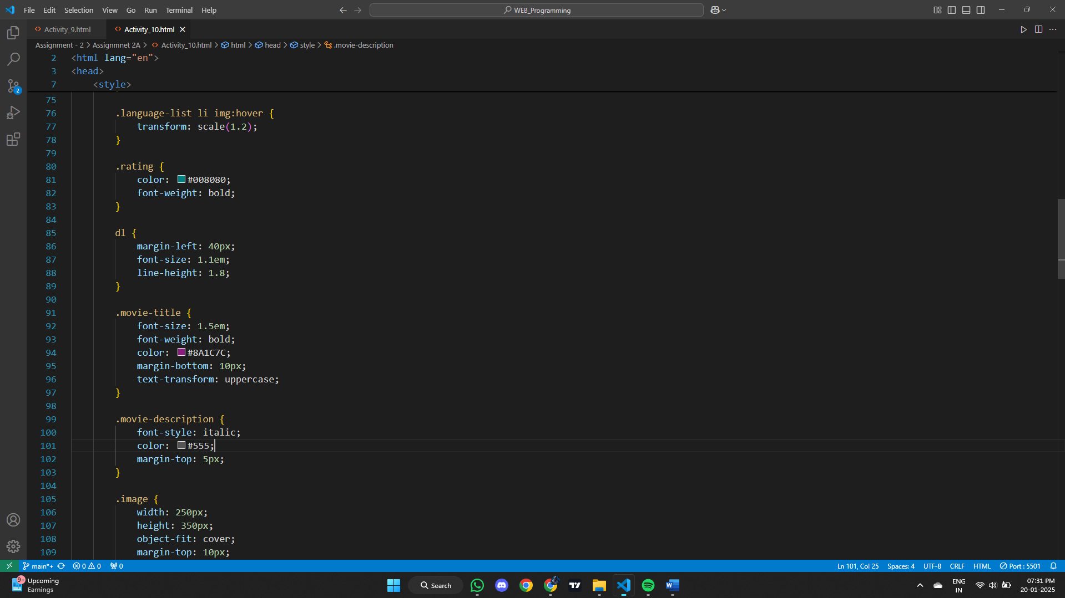

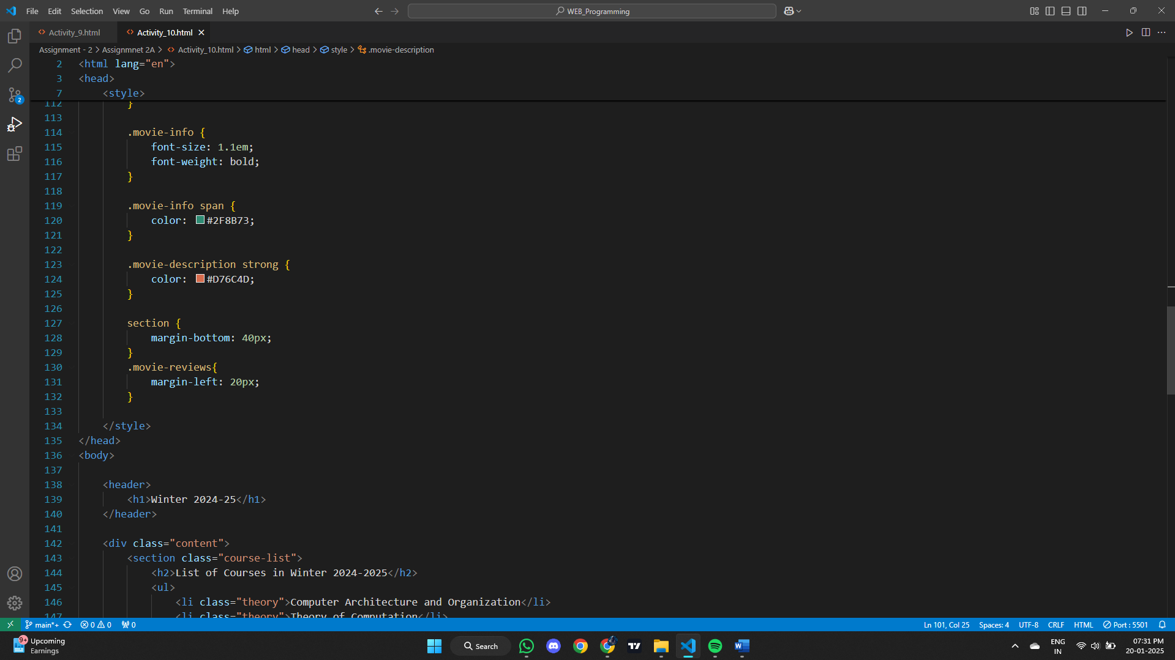

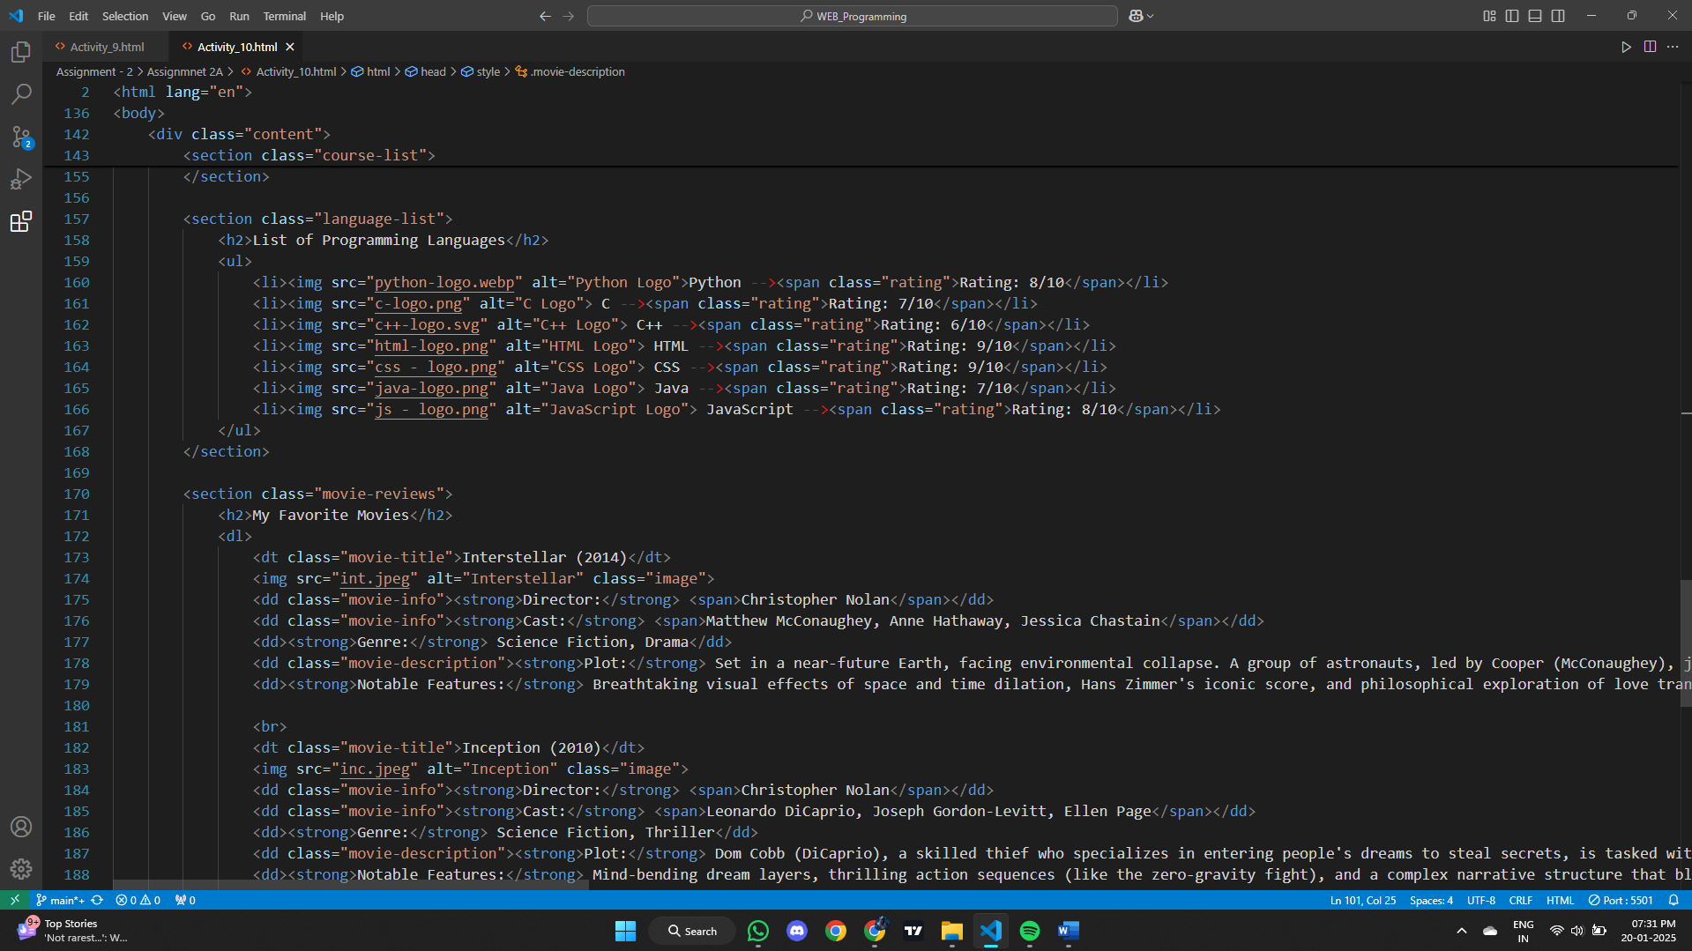

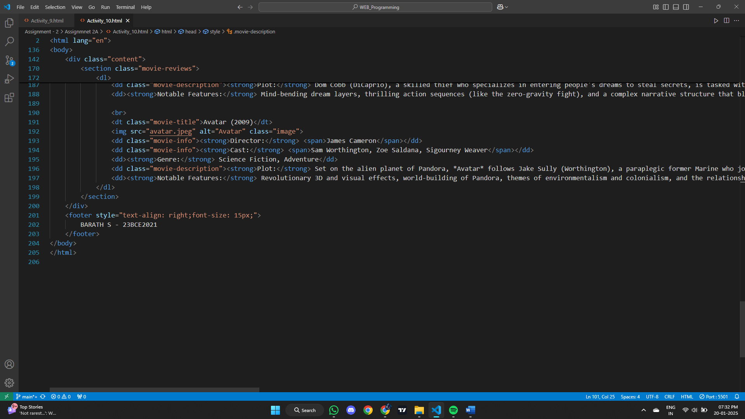

**Output:**

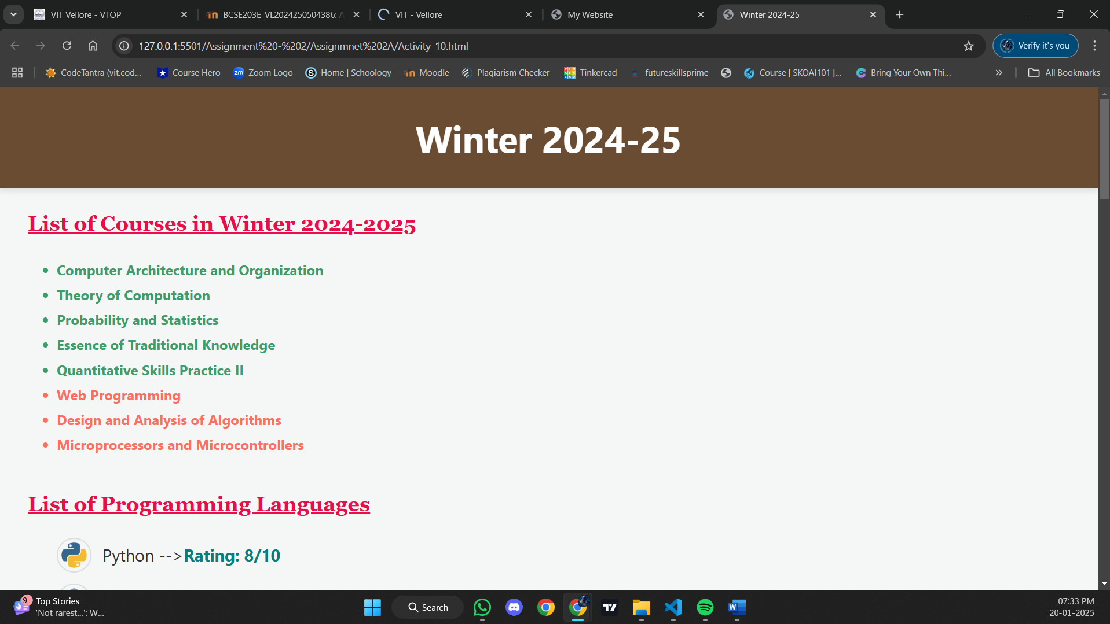

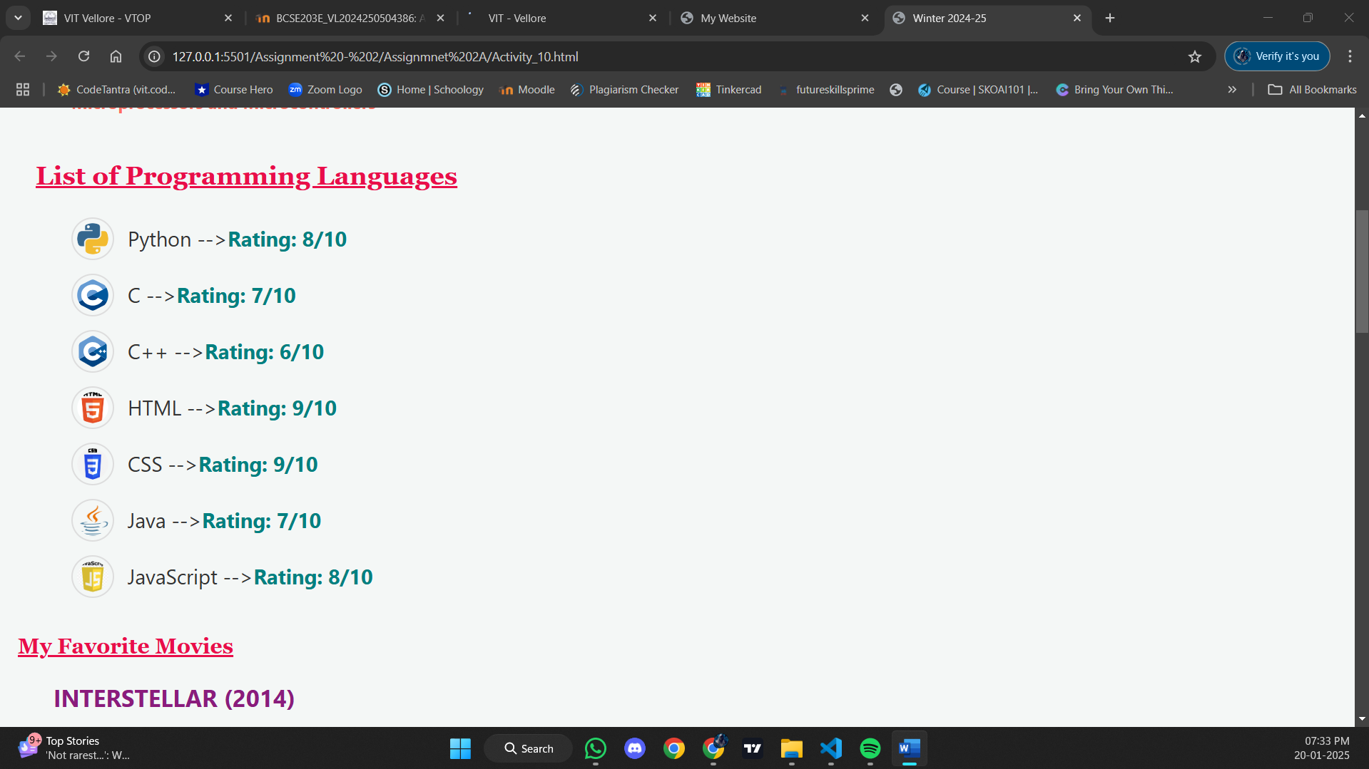

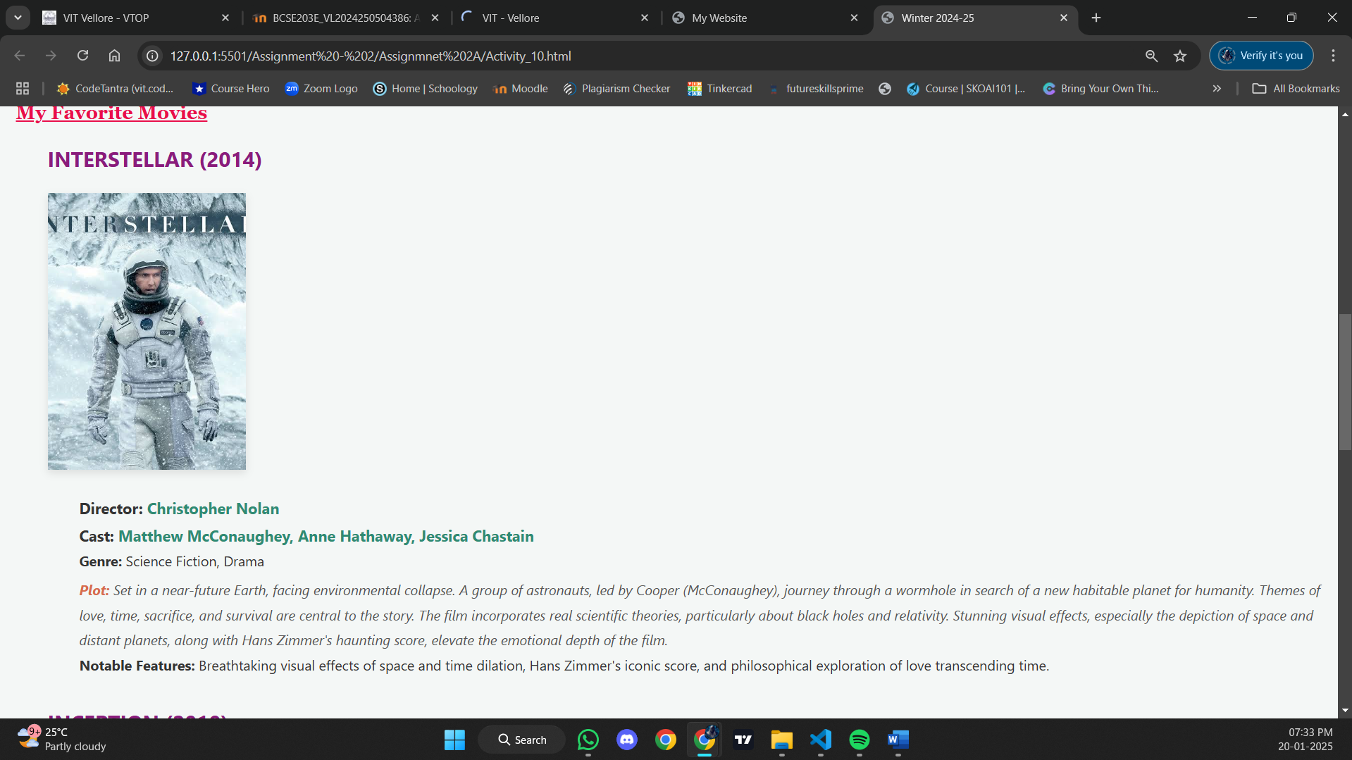

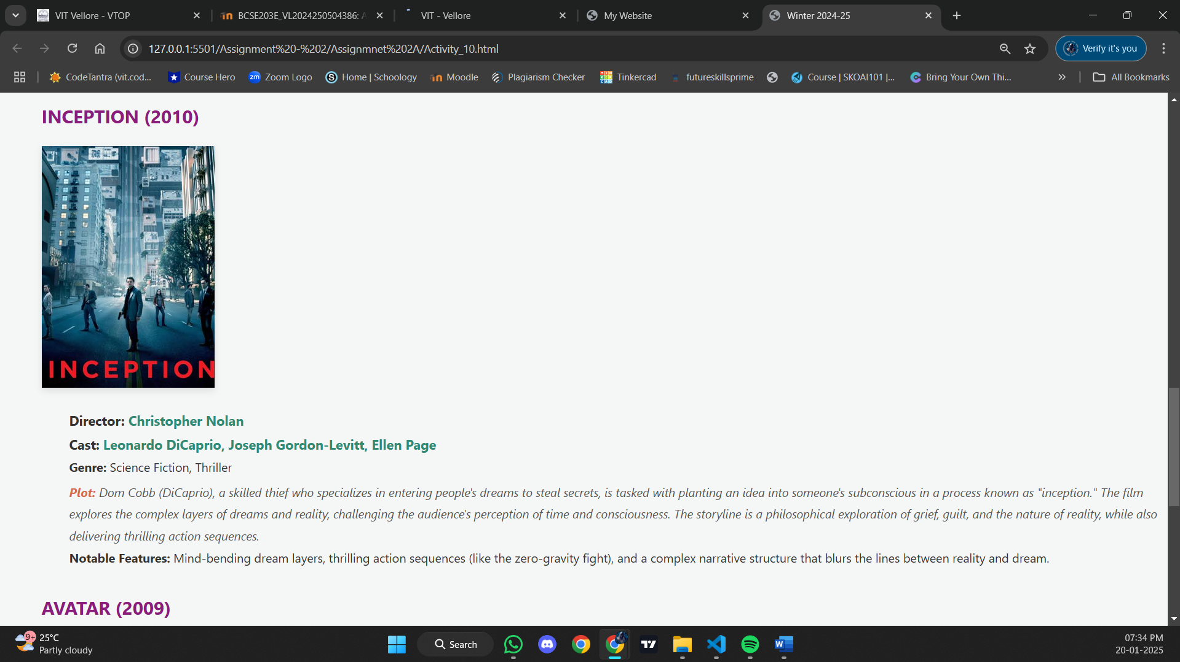

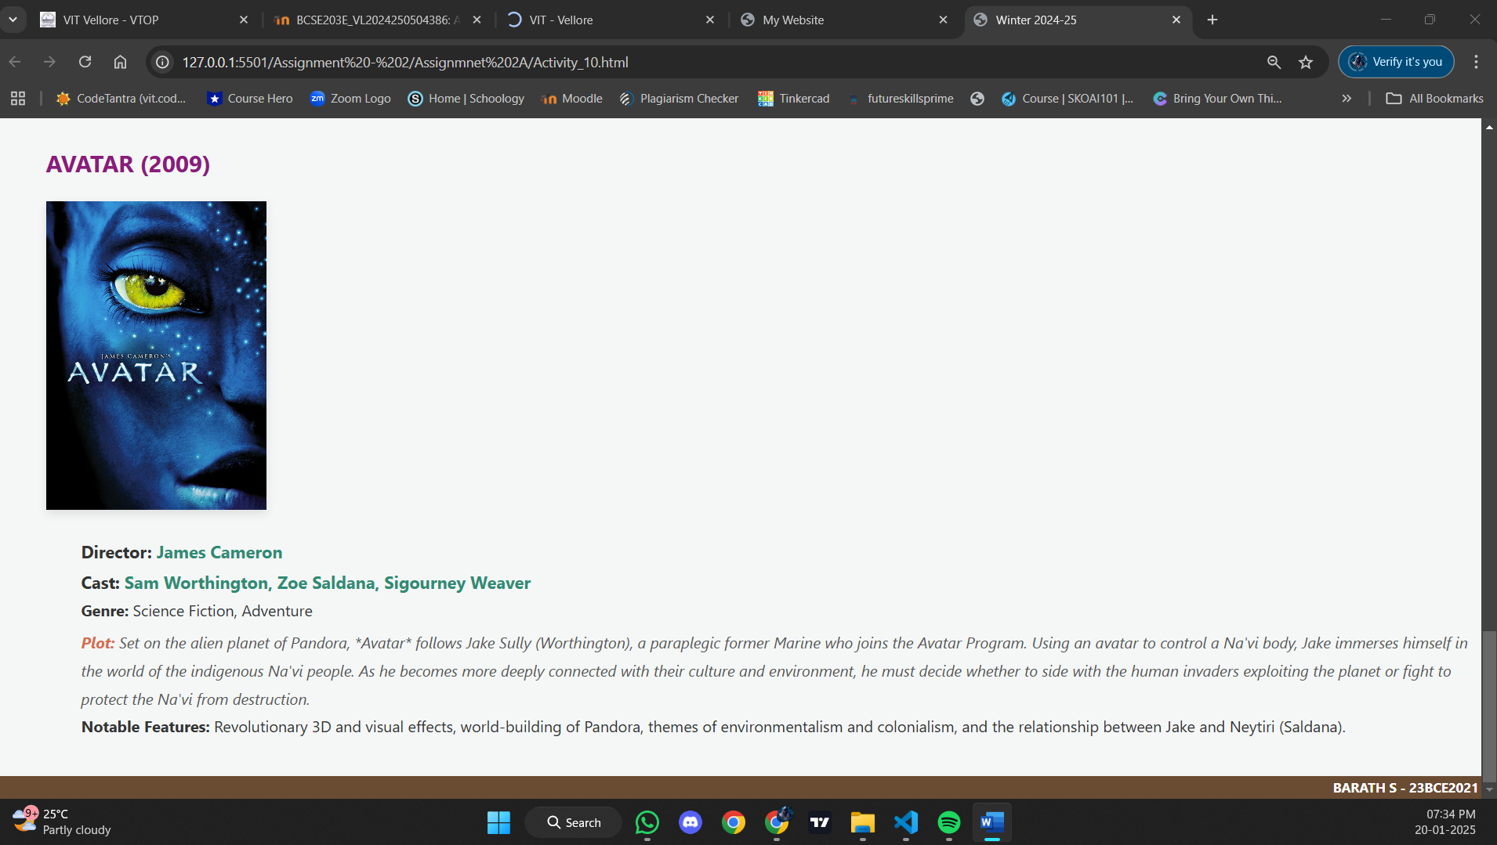

**Result:**

Thus, a web page design to replicate the above table and the output was verified.